

MBA633A  
MARKETING RESEARCH

INDIAN INSTITUTE OF TECHNOLOGY, KANPUR

Department of Industrial and Management Engineering

|  |  |
| --- | --- |
|  | Project Report  A Market Research project on  Vodafone Idea Ltd. |

|  |  |
| --- | --- |
| Submitted to:  Prof. Shankar Prawesh | Submitted by :  Danish Nawaz (18114008)  Dhruv Patel (181140010)  Karthik Ramakrishnan (18114012)  Motilal Meher (18114015) |

**PROBLEM DEFINITION**

Vodafone is British multinational telecommunications conglomerate with more than 470 Million customers across the globe. It is currently operating in India after merger with Aditya Birla Group’s Idea Cellular Limited, as Vodafone Idea Limited. As of November 2018, Vodafone Idea has 35.94% market share in India with 421.076 million subscribers, making it the largest mobile telecommunications network in India and second largest mobile telecommunications network in the world. Although company is currently in leadership position but it is facing fierce competition from old rival Airtel as well as emerging competitor Jio, which has conquered significant market share in very small span of time. Company is struggling to retain his old customers and apparently failing to get new customers in comparison with competitors.

**Management Decision Problem**

What steps should the management take to increase or retain its customers amidst fierce competition in Indian Telecommunication market?

**Market Research Problem**

* To find out the factors which are responsible for customer churning.
* To find out the criteria by which a customer chooses a network over another.
* To find out how good is the price structure of the plans when compared with the competitors.
* To find out which segment of customers are the most loyal.

**APPROACH TO THE PROBLEM**

**Focus Group and Personal Interviews**

The qualitative techniques of market research such as interview with decision makers and focus group were conducted to gain a first-hand insight of the problem. Attendees of the focus group was a bunch of our classmates who represent the cities that we focused on in this research. We also had a telephonic discussion with one of the company executive regarding the research problem to get the companies POV.

**Theoretical Frameworks**

The motive behind the conduction of this research is to find the parameters that an individual deems important for selecting a telecommunication network. Also, we aim to provide our analysis to the management that can be useful for it to formulate a solution to the management decision problem. The underlying assumption is that there are various factors that motivate a person’s choice.

1. **Verbal Model**

This model says that the awareness about the different telecommunication network is primary and a person’s evaluation of a network under the light of various judgement criterion comes next. His/Her judgement on those criterion decides his/her preference of a particular network over another.

1. **Graphical Model**

This model designs an interrelation relation between myriad variables going in the research model. The models complement each other to understand the causality of the factors of selecting any food joint by helping in identification of research questions and hypotheses.   
  
See **Appendix 1** for Graphical Model we are employing in our research.

**Research Questions and Hypotheses**

|  |  |  |
| --- | --- | --- |
| **S. No.** | **Research Question** | **Hypothesis** |
| **1** | Can customers be segmented based on psychographic characteristics? | There are distinct segments of customers. |
| **2** | Each segment is motivated to use a network for a different reason |
| **3** | Brand Loyalty is high among Vodafone customers in all segments. |
| **4** | What are the possible reasons for customer churn? | Customer dissatisfaction towards Vodafone |
| **5** | Emergence of Jio |

# **Factors Influencing the Research Design:**

The factors influencing the Research Design of the problem in hand are:  
 1.Availability of Secondary Data.  
 2. Proper choosing of variables addressing our Market Research Problem.  
 3. Unbiased answers of survey takers.

**RESEARCH DESIGN**

**Survey Preparation Method:**

The questions of the survey were framed using focus group discussions in which the

participants shared about the features that they consider while selecting telecom service.

**Focus group** comprised PG students. There were 8 students, 5 males and 3 females.

**Scaling techniques:**The scaling technique used in the survey are Rank order comparative scaling for understanding the choices made by a person on several factors. Rank order scaling is used when telecom companies are ranked according to the different criteria mentioned in the questions. Five point Forced rating scales (non comparative) are used I which can be easily ensured in the **google form** that we used to conduct the survey to understand the various service provided by Vodafone Idea ltd

**Questionnaire development and pretesting:**

The questions were structured to avoid ambiguity and were kept neutral in nature to ensure the respondents are unbiased. **Pretesting** of the questionnaire was done on a sample of 5 students which helped in making the survey questionnaire more objective and precise.

See **Appendix 2**for Questionnaire.

**Sampling techniques:**

So, the target audience is from four major states in India viz Tamil Nadu, West Bengal, Uttar Pradesh and Gujarat. The **sample size collected is 444**. Sample technique was completely random where **Sampling frame** is active social media user account. Reward in paytm/UPI was offered to randomly selected respondents for filling the survey.

**Fieldwork:**

The survey has been administered through online mode. We deployed it in a Google form. The online mode was chosen for the convenience of the customer as the open internet Google form was floated because it can be easily accessed with a smartphone and works even during weak network.

**Data Analysis:**

First we filter out respondent based on the primary sim card that they are using currently. Those who were using vodafone-idea as their primary sim card were asked to rate Audio call quality, Internet speed, how cost effective is the existing plans and How satisfied are they with the customer service in a scale of 1-5. Where 1 stands for very bad service and 5 stands for very good service. Respondent were asked to rate.

We found that the existing plans received a neutral rating of 3.06 followed by customer services which received an average rating of 3.50. So the current customer are not very satisfied with the customer services and cost of plans which support our hypothesis for customer churning.

|  |  |  |  |
| --- | --- | --- | --- |
| Audio call  Quality | Internet speed | Cost effective plan | Customer service |
| 4.12 | 3.71 | 3.06 | 3.50 |

For the other respondents who were not using vodafone-Idea as their primary sim card currently we asked if they had ever used vodafone-Idea. The people who responded positive were further asked Why you switch to other telecom provider. 28% of the respondent marked Price benefits and 32% of them marked customer services as their major reasons to switch.

Also, analysis was done to know why people who have ever used Vodafone-Idea but now using JIO. The results was in tandem with above observations and we concluded that the emergence of JIO arouse a sensation of price benefits to existing Vodafone-Idea customers which resulted in customer churning.

1**. Occupation vs Recommendation Cross Tabulation:**

In this test we tried to test the null hypothesis that occupation does not affect brand loyalty. But the chi- square test results proved it statistically that indeed it does affect the brand loyalty and we had to reject the null hypothesis.



**2. Gender vs Preference cross tabulation:**

Here we tested the null hypothesis that male and female have same preferences, when it comes to type of service preferred and we rejected this null hypothesis statistically using chi-square test.So there is an association between gender and service preference.

**3. Occupation vs Preference cross tabulation**:

Here we tried testing the null hypothesis that occupation has no effect on preferences. But surprisingly the chi-square test showed that it does effect and there is an association between them.





**4. States vs Internet rating:**

Here we tried to test if the customer’s behavior towards Internet service depends ondemographics or not. Surprising after performing ANOVA test, we found that all states have different rating means and company needs to come up with policies according to that particular region rather than going for generalpolicies**.**

**5.Age vs Preference Cross Tabulation:**



Here null hypothesis is that there is no relationship between Age and preference. Chi-square test statistically reject the null hypothesis.so there is a relationship between these two and age does affect preference of services.

**6. Age groups Vs Plan Ratings ANOVA TEST:**

Here Null hypothesis is that there is no difference in impression about existing plans across age groupsand we statistically reject the null hypothesis and we came to conclusion that current plans have mixed perspectives around different age groups and company must customize plans for each age group.

7. **Occupation Vs AudioQualityANOVA TEST:**

Here Null hypothesis is that there is no difference in impression about existing plans across customers having different occupation but here also we statistically reject the null hypothesis which strongly suggest tocustomize plans for each different type of user.



**8. States Vs Plan Ratings ANOVA TEST:**

Here Null hypothesis is that Audio quality is same for different state. And we statistically reject null hypothesis i.e Audio quality vary from state to state.

**Results**

1.*CROSS TABULATION*: Occupation vs Recommendation.

The occupation of the respondent was broadly classified into 4 categories (Student, Working Professional, Self Employed, Others) and Recommendation was measured in a scale of 1-5 where 1 was Not Recommended and 5 was Highly Recommended. The null hypothesis was “Occupation does not affect Brand Loyalty”. We performed chi-square test that statistically proved the null hypothesis to be wrong, that a person’s occupation does affect the brand loyalty. So we had to reject the null hypothesis.

2.*CROSS TABULATION*: Gender vs Preference:

The gender was a categorical variable with three categories (Male , Female and Transgender) and Preference was also a categorical variable with three categories (Calls, Internet, SMS) . The null hypothesis was “ Male and Female have the same preference”. We again performed a chi-square test which proved our null hypothesis to be true.

3.*CROSS TABULATION*: Occupation vs Preference:

We already know about the variables Occupation and Preference from the above mentioned results. This time we tried testing the null hypothesis “Occupation has no effect on Preference”. We used chi-square test which failed to accept the null hypothesis. This matched our intuition that people in different occupation have different needs.

4.*ANOVA*: State vs Internet Rating:

Since we had distributed our forms to each of our own states , there were 4 different states of India ( West Bengal , Tamilnadu , Uttar Pradesh and Gujarat) and Internet Rating was measured in a scale of 1-5 where 1 was Least Satisfied and 5 was Highly Satisfied. Suprisingly ,after performing ANOVA test , we found that different states have different needs. So in-order to survive in this kind of a market a company should not promote a generalized pan India plan. Instead they should address the needs of different states with different plans.

5. *CROSS TABULATION*: Age vs Preference:

Age in years was again a categorical variable with 5 levels (10-19 , 20-25 , 26-30 , 31-40 , 40-50) and Preference was a categorical variable with 3 levels (Internet , Calls , SMS). After performing a chi-square test , we statistically failed to reject the null hypothesis that “Age has no effect on Preference”.

6.*ANOVA*: Age vs Plans Being Economical:

Age like mentioned before was a categorical variable with 5 levels and Plans being Economical was measured in a scale of 1-5 where , 1 was Lease Economical and 5 was Highly Economical. Our Null hypothesis was “Exisiting plans of Voda-Idea Ltd. is equally economical for all age groups. The ANOVA test that we made on this hypothesis made us to reject the null hypothesis and hence proved the opposite that “Existing plans are not equally economical for all age groups”.

7. *ANOVA*: Occupation vs Plans Being Economical:

The variables Occupation and Plans Being Economical have already been discussed earlier. The null hypothesis this time was “ Existing plans of Voda-Idea Ltd. is equally economical for people with different occupation. After performing an ANOVA test on this null hypothesis we statistically reject the null hypothesis and hence we proved that “The existing plans are equally economical for people with different occupation”.

8.*ANOVA*: Audio Quality vs State:

State like we have mentioned earlier was a categorical variable with 4 categories and Audio Quality was measured in a scale of 1-5. Our Null hypothesis was “Audio Quality is same for different States”. We performed an ANOVA test to check the hypothesis and we statistically rejected the null hypothesis which proved that “Audio Quality does vary from state to state”.

# **LIMITATIONS AND CAVEATS**

* Due to large Customer base of vodafone-Idea, the true population size was very large. We collected only 444 samples from the populations which barely represents the population.
* Data errors due to question non-responses may exist. The number of respondents who choose to respond to a survey question may be different from those who chose not to respond, thus creating bias.
* Since we had written in the Disclaimer of the front page of the survey there could have been some respondents who would have answered the survey just for the "Lucky Draw". This would have created some biased responses on the questionnaire

**CONCLUSION**

* 81% of the users, who are currently using Vodafone-Idea, are their old customers. Which shows decline in number of new customers.To attract new customers, company should first segment the customers and target different segments with different type of advertisement/ offers based on their preference.
* 32% of the customers who have churned from Vodafone-Idea to other company marked customer service as the reason for churning while 28% have marked price benefits by competitors. This indicates that company must improve his customer service and also should come up with new, economical plans by keeping in mind about the popular plans of other rival companies.
* We analyzed effect of emergence of JIO separately and found that 48% of the customers switched to JIO from Vodafone-Idea just because of cost benefits, So company must understand that in a price sensitive market such as India, making economical plans is very essential.

**APPENDIX 1:**

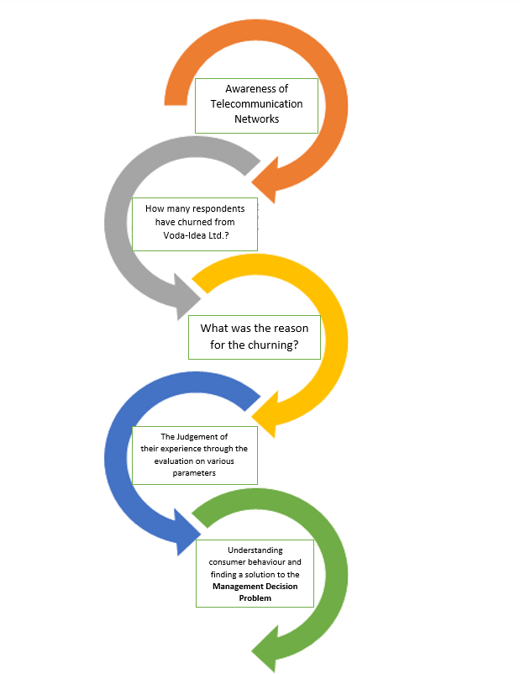**APPENDIX 1:**

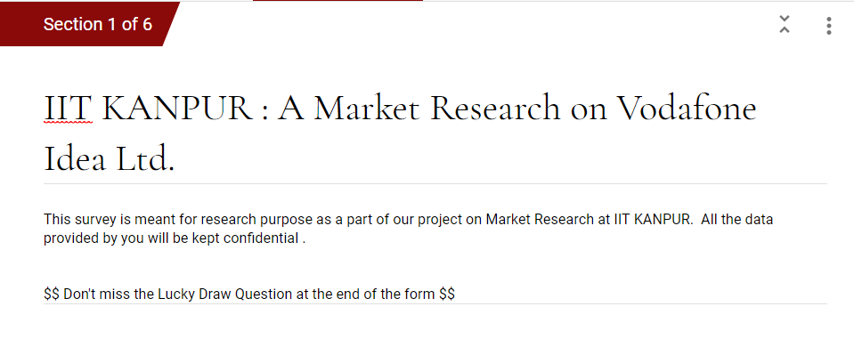**APPENDIX 2:**

